Recursive Algorithm/Function Practice Question

Write a recursive method to find the minimum value in an unsorted integer array.  (Note: The data type of the array is int, which could be a negative value, 0 or a positive value.)

**Recursive Algorithm**

Here is my version of the recursive algorithm:﻿﻿﻿﻿﻿﻿

Let's say **n** is the size of the array. Then  **n**th element value is array[**n-1**]. **F**(n) is our recursive function.

**Base case**:

**F**(1) = array[0] = array

**General case**:

**F**(**n**) = minimum{array[**n-1**], **F**(**n-1**)} //The smaller one between nth element value and F(n-1).

*Note*:

F(n-1) returns the smallest value among the next n-1 elements.

In other words, F(n-1) = minimum {array[(n-1)-1), F(n-2) }

                          F(n-2) = minimum{array[(n-2)-1), F(n-3) }

…

**Recursive Function**

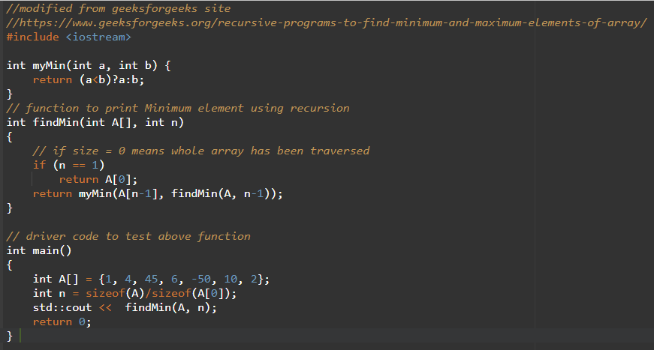

﻿<https://www.geeksforgeeks.org/recursive-programs-to-find-minimum-and-maximum-elements-of-array/>

**Tail Recursive Function**

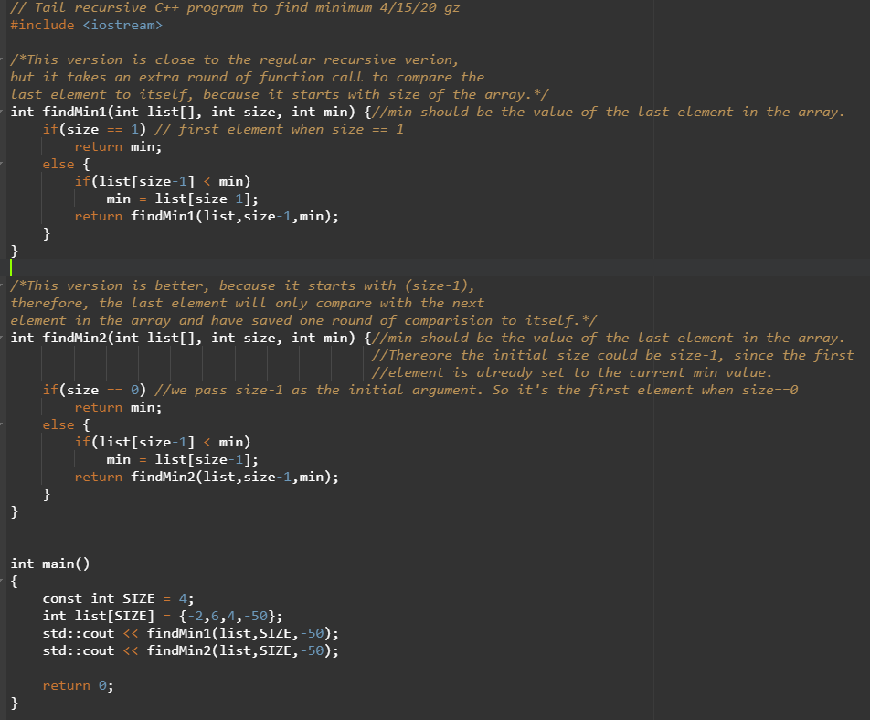

[cpp.sh/82ryj](http://cpp.sh/82ryj)